**May 5 Lab questions**

#1.WAP to generate all the prime numbers between 1 and n by using a user

defined function (say isPRIME) to be used for prime number testing, where n

is a value supplied by the user.

Code:

#include <stdio.h>

void PRIME(int n)

{

    int i_285,count_285,j_285;

    for(i_285=2;i_285<=n;i_285++)

    {

        count_285=0;

        for(j_285=1;j_285<=i_285;j_285++)

        {

            if(i_285%j_285==0)

            {

                count_285++;

            }

        }

        if(count_285==2)

        {

            printf("%d ",i_285);

        }

    }

}

int main()

{

    int num;

    printf("Please provide the range of prime numbers you want to be printed out\n");

    scanf("%d",&num);

    printf("The prime numbers between 1 and %d are as follows==\n",num);

    PRIME(num);

    return 0;

}

Output:

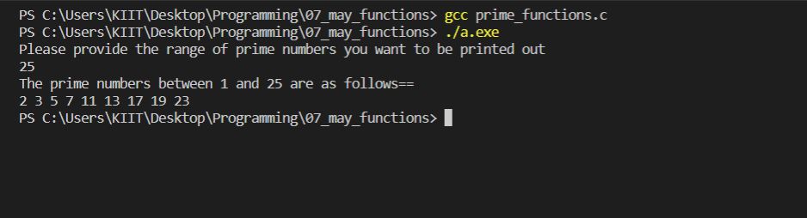

#2. WAP to compute the cosine series using function.

Code:

#include <stdio.h>

#include <math.h>

const float PI = 3.142;

float fact(int f)

{

    float i_285,n;

    n=f;

    for(i_285=1;i_285<f;i_285++)

    {

        n=n*(f-i_285);

    }

    return n;

}

float COS(float x, float n)

{

    int i_285,j;

    float sum_285,qoutient_285,a,b,c;

    x = x * (PI / 180.0);

    sum_285=0;

    for(i_285=1;i_285<n;i_285++)

    {

        if((i_285%2)!=0)

        {

            c=i_285*2;

            a=-(pow(x,c));

            b=fact(c);

            qoutient_285=a/b;

        }

        else if((i_285%2)==0)

        {

            c=i_285*2;

            a=pow(x,c);

            b=fact(c);

            qoutient_285=a/b;

        }

        sum_285=sum_285+qoutient_285;

    }

    return sum_285;

}

int main()

{

    float num,n;

    float result;

    printf("Please provide the number of terms u want to add\n");

    scanf("%f",&n);

    printf("cosine of which number do you want to be printed\n");

    scanf("%f",&num);

    result=1+COS(num,n);

    printf("Cosine of %f is %f\n",num,result);

    return 0;

}

Output:

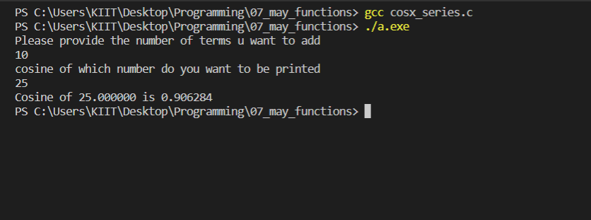

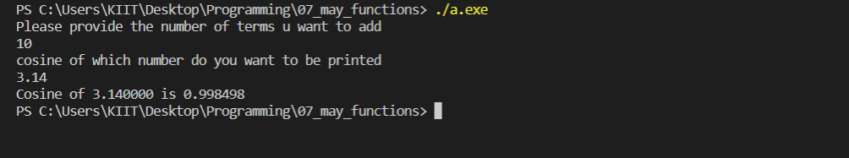

#3. WAP to count number of digits of a positive integer n by using recursion.

Code:

#include<stdio.h>

int count(int num_285)

{

    int digit_285;

    if(num_285==0)

    {

        return 0;

    }

    else

    {

        digit_285=1+count(num_285/10);

    }

    return digit_285;

}

int main()

{

    int numb_285,n_285;

    printf("Please provide the number\n");

    scanf("%d",&numb_285);

    n_285=count(numb_285);

    printf("The number of digits in %d is==%d\n",numb_285,n_285);

    return 0;

}

Output:

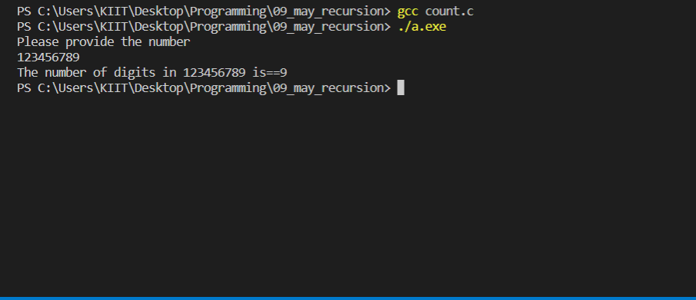

#4. WAP to find out the sum of n elements of an integer array a[] by using

recursion.

Code:

#include <stdio.h>

int SUM(int A_285[],int n_285)

{

    int sum_285,b;

    if(n_285==0)

    {

        return A_285[0];

    }

    else

    {

        sum_285=A_285[n_285]+SUM(A_285,n_285-1);

    }

    return sum_285;

}

int main()

{

    int i,A_285[30],num_285,sum_285;

    printf("Please provide the number of your elements\n_285");

    scanf("%d",&num_285);

    printf("Please provide the elements of your list\n_285");

    for(i=0;i<num_285;i++)

    {

        scanf("%d",&A_285[i]);

    }

    sum_285=SUM(A_285,num_285-1);

    printf("The sum of your elements is %d\n_285",sum_285);

}

Output:

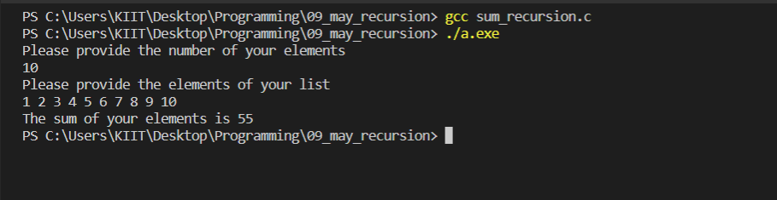

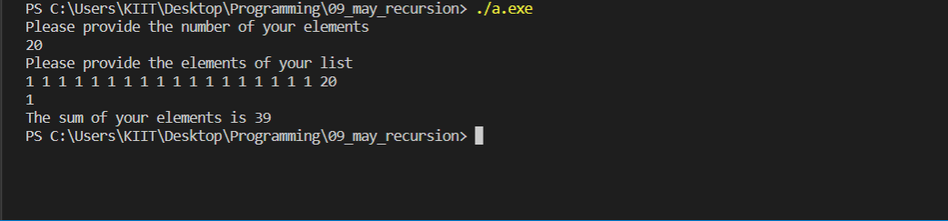

#5. WAP to add two numbers using call by reference.

Code:

#include<stdio.h>

int main()

{

    int num1_285, num2_285, sum_285;

    int *ptr1_285, *ptr2_285;

    printf("Enter any two Number: ");

    scanf("%d%d", &num1_285, &num2_285);

    ptr1_285 = &num1_285;

    ptr2_285 = &num2_285;

    sum_285 = *ptr1_285 + *ptr2_285;

    printf("\nSum of %d and %d is %d", *ptr1_285, *ptr2_285, sum_285);

    return 0;

}

Output:

